**Real-time Intrusion Alert System**



# ABSTRACT: -

Security Alarm is a very useful device to detect intrusion in our home while we are away. However, a security alarm system is very costly. Therefore, a custom-made ultrasonic security system is a cost-effective way to make sure we have a working alarm which is a fraction of cost of a normal security alarm available in the market

# COMPONENTS REQUIRED: -

* 1. Arduino UNO
  2. USB 2.0 cable
  3. Ultrasonic Distance Sensor - HC-SR04
  4. Buzzer
  5. Resistors- 220 ohm - 4
  6. Connecting wires
  7. Bread Board

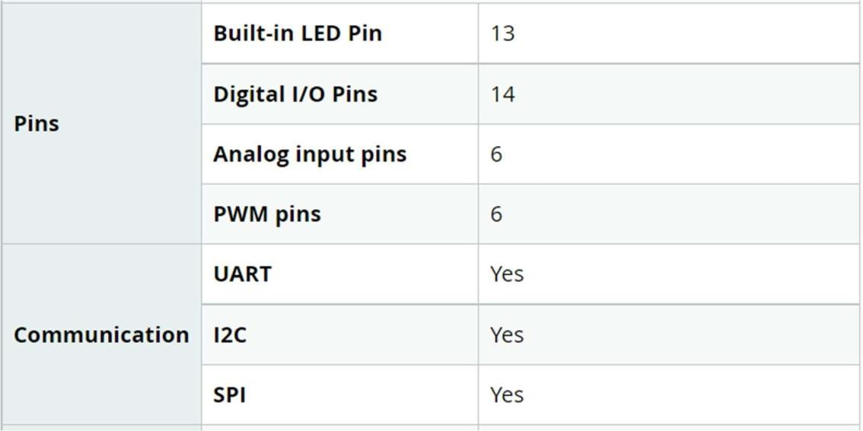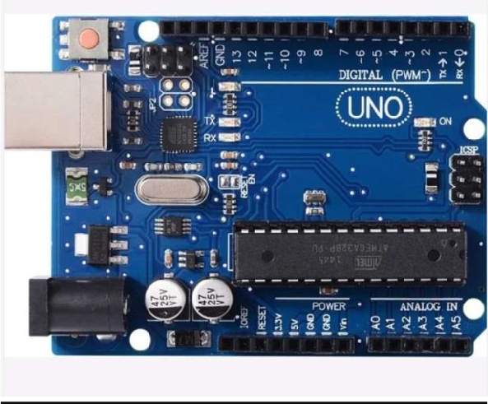

Arduino UNO r3:

Arduino UNO is a microcontroller board based on the ATmega328P. It has 14 digital input/output pins (of which 6 can be used as PWM outputs), 6 analog inputs, a 16 MHz ceramic resonator, a USB connection, a power jack, an ICSP header and a reset button. It contains everything needed to support the microcontroller; simply connect it to a computer with a USB cable or power it with a AC-to-DC adapter or battery to get started. One can tinker with their UNO without worrying too much about doing something wrong, worst-case scenario you can replace the chip and start over again.

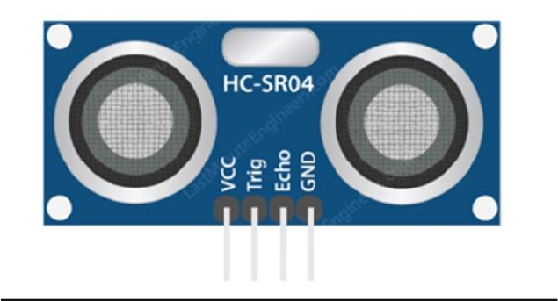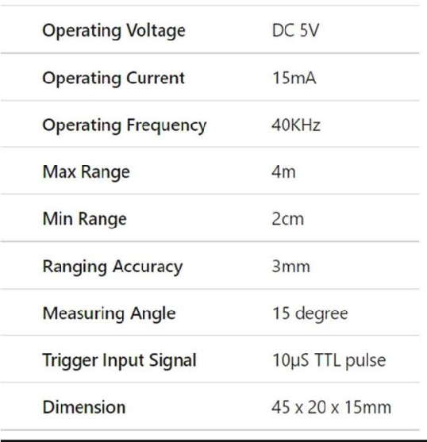

An HC-SR04 ultrasonic distance sensor actually consists of two ultrasonic transducers. One acts as a transmitter that converts the

electrical signal into 40 KHz ultrasonic sound pulses. The other acts as a receiver and listens for the transmitted pulses. When the

receiver receives these pulses, it produces an output pulse whose width is proportional to the distance of the object in front.

This sensor provides excellent non-contact range detection between 2 cm to 400 cm (~13 feet) with an accuracy of 3 mm. Since it

operates on 5 volts, it can be connected directly to an Arduino or any other 5V logic microcontroller.

## Buzzer:

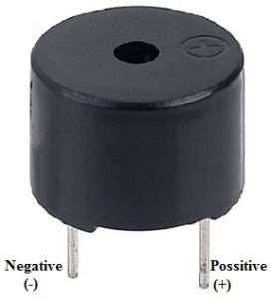

An audio signaling device like a beeper, it is a electromechanical or piezoelectric or mechanical type. The main function of this is to convert signal from audio to sound. Generally, it is powered through DC voltage and used in timers, alarm devices, printer etc. Based on the various designs, it can generate different sound like alarm, music, bell and siren.

.

The pin configuration of the buzzer is shown above. It includes two pins namely positive and negative. The positive terminal of this is

represented with the ‘+’ symbol or a longer terminal whereas the negative terminal is represented with the ‘-’ symbol or short

terminal.

## Resistors:

A resistor is a passive two terminal electrical componenet that implements electrical resistance as a circuit element. In

electronic circuits, resistors are used to reduce current flow, adjust signal levels, divide to voltages, bias active elements, and terminate transmission lines, among

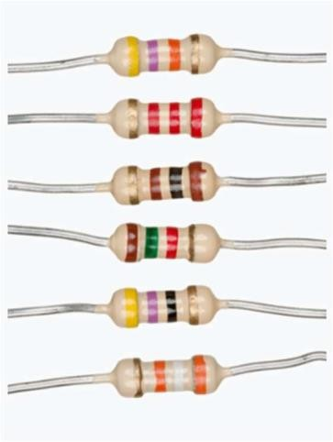

other uses. High-power resistors that can dissipate many watts of electrical power as heat may be used as part of motor controls, in power distribution systems, or as test loads for generators. Fixed resistors have resistances that only change slightly with

temperature, time or operating voltage. Variable resistors can be used to adjust circuit elements (such as a volume control or a lamp dimmer), or as sensing devices for heat, light, humidity, force, or chemical activity.

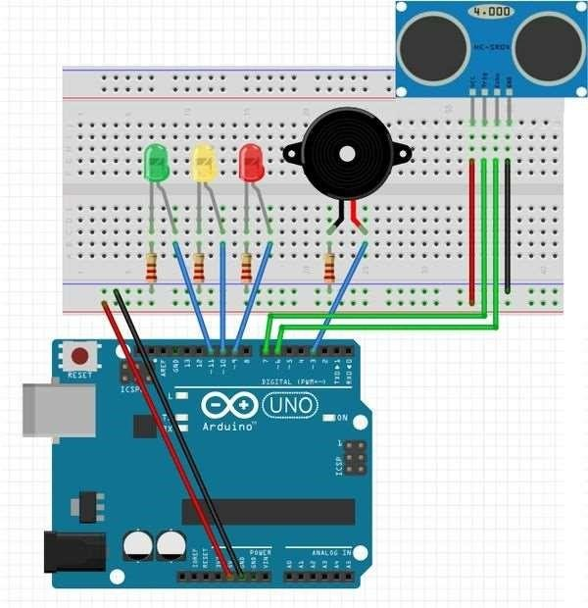

# CIRCUIT DIAGRAM: -

**EXPERIMENTATION: -**



Connect the 5V and GND pin on the Arduino to the breadboard. be sure that the wire attached to the 5V pin is connected to the positive channel of the

breadboard, and the wire attached to the GND pin is connected to the negative channel of the breadboard.

Connect the GND pin on the ultrasonic sensor to the negative channel on the breadboard. Next connect the Trig pin on the sensor to pin 2 on the Arduino and connect the Echo pin on the sensor to pin 3 on the Arduino. Lastly, connect the VCC pin on the ultrasonic sensor to the positive channel on the breadboard.

Connect the anode (the longer leg) of LED1(white) to pin 6 on the Arduino, and to connect the cathode (the shorter leg) to the negative channel on the

breadboard, using a 220-ohm resistor. Then repeat that step for the second and then the third LED, make sure to connect the anode (the longer leg) of the LED2(green) to pin 5 on the Arduino and then connect the anode of the LED3(red) to pin 6.

Connect the longer leg of the buzzer to pin 7 of the Arduino using a wire and then connect the shorter leg of the buzzer to the negative channel of the

breadboard using a 220-ohm resistor.

Ultrasonic sensors work by sending out a sound wave at a frequency above the range of human hearing. The transducer of the sensor acts as a microphone to receive and send the ultrasonic sound. Ultrasonic sensors, like many others, use a single transducer to send a pulse and to receive the echo.

The sensor determines the distance to a target by measuring time lapses

between the sending and receiving of the ultrasonic pulse. All the commands

will be stored in the Arduino and it will power the ultrasonic sensor. If the

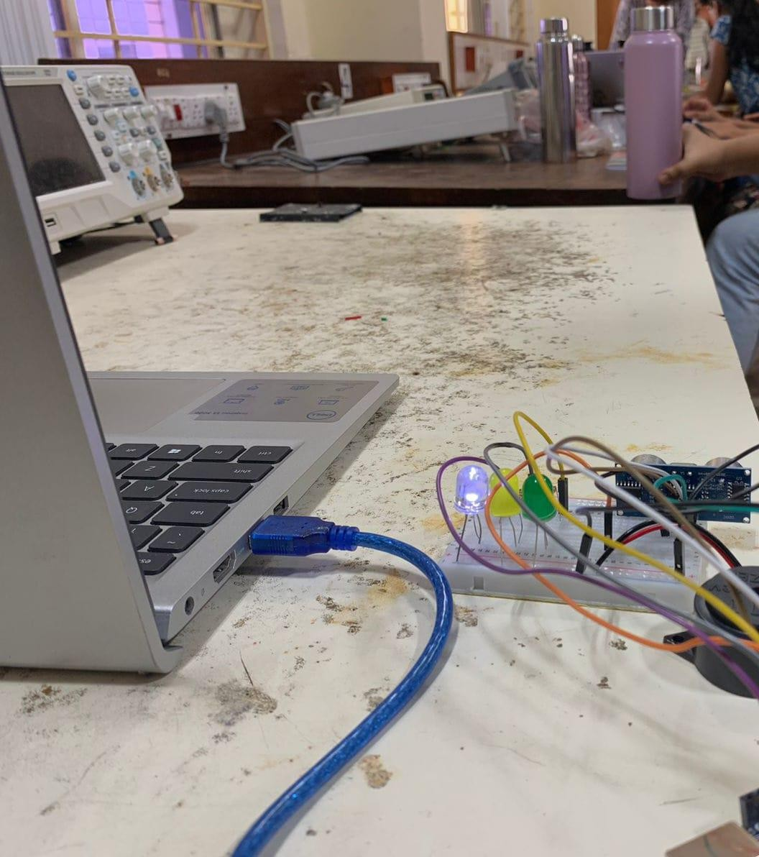

distance to the target is within the specified range the sensor will send a signal to the buzzer and the LEDs.

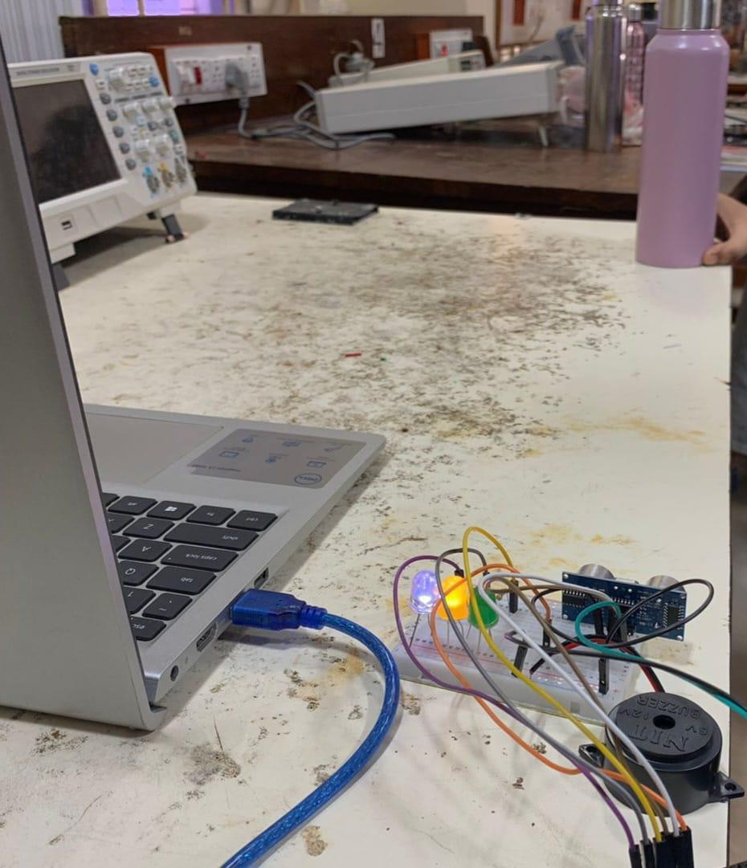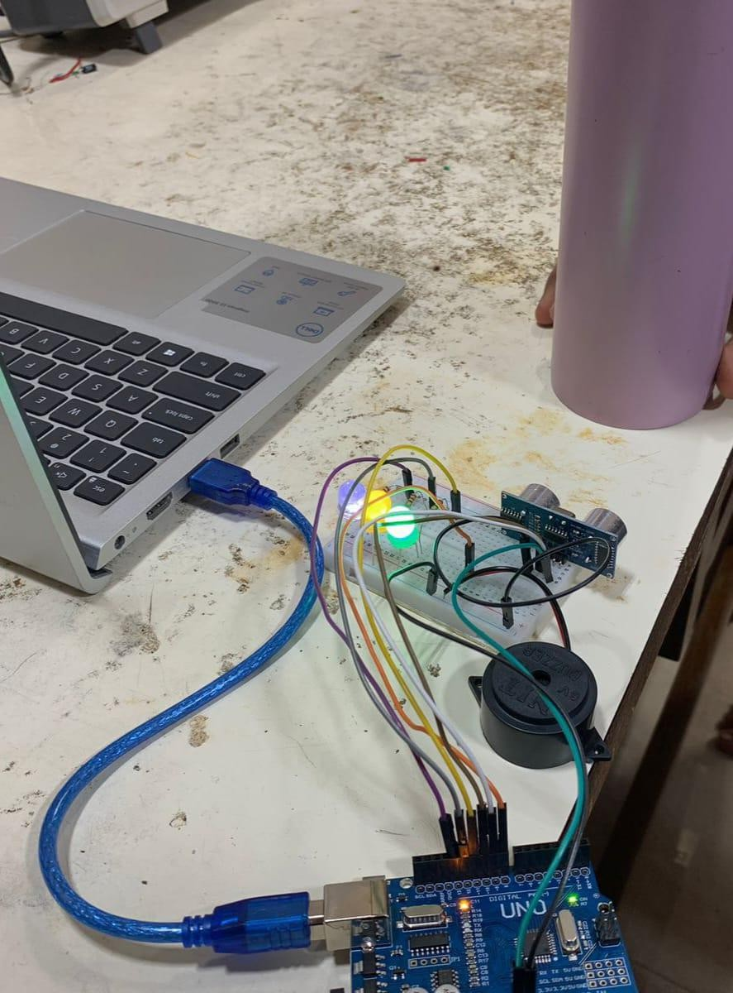

# APPLICATIONS: -

* **Object detection on conveyor belts**
* **Obstacle detection in automated robot**
* **vacuum cleaners**
* **Security alarm**
* **Liquid level sensing**
* **Anti intrusion system**